Invitation to international conference and seminar
"Alders and other fast growing trees"
April 29–30, 2019
Kalsnava, Latvia
The objective of the conference is to present ongoing research in Nordic & Baltic countries and to discuss future research needs. Working language is English.
Researchers, master students and PhD-students, as well as people from forest management are welcome for participation in the conference and following seminar.
Time scheduler in April 29 starts with lunch at 13:00 |  | Presenter | Country
14:00 | Welcome speech | Jurgis Jansons,  LSFRI Silava | LV
14:10 | Climate and Fast growing trees | Aris Jansons,  LSFRI Silava | LV
14:30 | Genetic adaptation in fast growing forest trees | Egbert Beuker,  LUKE | FI
14:50 | Carbon studies in Grey alder and Silver birch ecosystems in Estonia | Jürgen Aosaar and  Veiko Uri, EMU | EE
20 minutes | Coffee
15:30 | Biomass studies in grey alder and common alder stands | Kaspars Liepiņš and Jānis Liepiņš,  LSFRI Silava | LV
15:50 | Alders and other fast growing trees on peatlands | Jyrki Hytonen, LUKE | FI
16:10 | 1 minute Poster Pitch session
20 minutes | Coffee /and Posters
16:50 | Breeding of Alnus glutinosa | Virgilijus Baliuckas, LRCAF | LT
17:10 | Research on Alnus incana in Sweden | Lars Rytter, Skogforsk | SE
17:30 | Hybrid alders | Dagnija Lazdina, LSFRI Silava | LV
17:50 | Summary
19:00 | Dinner
 | Sauna & Discussions

Time scheduler for seminar, April 30
8:00 | Breakfast
8:40 | Identification of Future research needs
10:00 | Departure to research objects
10:20–11:20 | Management of grey alders
 | Drive to next object
11:40–12:30 | Hybrid aspen coppice & Black alder seed orchard
 | Drive to next object
13:30 | Lunch at “Klidziņa”
14:50 | Fast growing trees on former arable land
16:00 | Departure to Airport Riga
17:30 | Arriving at Airport Riga

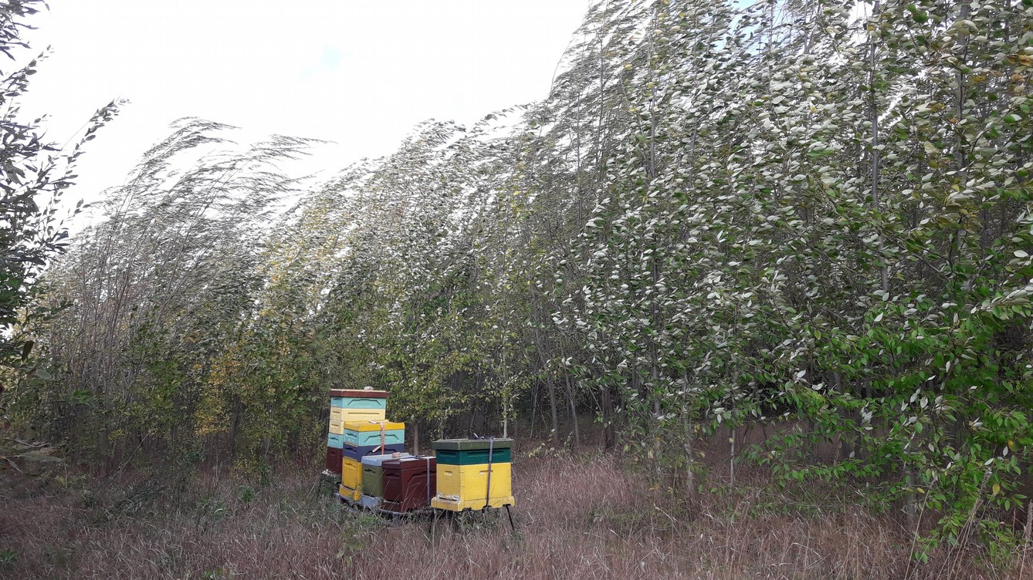

Arriving April 29 morning 9:00–10:00 pickup at Airport Riga
Transport to Forest research station guest house “Vētraine” (Kalsnava region)

Registration is open till April 22 by link
Participants, who want to make the poster presentations, should do registration and send a tentative title to organizers before April 15!

Contact information:
dagnija.lazdina@silava.lv


Support to the LSFRI Silava for international collaboration projects in research and innovation
European Regional Development fund project (No. 1.1.1.5/18/I/010)

